Readme

This microservice receives a request from the sender and returns a JSON object that contains a random bird species along with a description of the sighting with the latitude and longitude. To receive the JSON object with the bird sighting information, you must send a request using RabbitMQ. An example request is shown below in Python.

# Connect to RabbitMQ

connection = pika.BlockingConnection(pika.ConnectionParameters('localhost'))

channel = connection.channel()

# Declare a queue for the response

result = channel.queue_declare(queue='', exclusive=True)

callback_queue = result.method.queue

# Define the function to handle the response

def on_response(ch, method, props, body):

if props.correlation_id == corr_id:

data = json.loads(body)

print(f"Received response: {data}")

channel.stop_consuming()

# Generate a correlation ID for the request

corr_id = str(uuid.uuid4())

# Define the request message

message = "Request for bird sighting"

# Send the request message and wait for the response

channel.basic_publish(exchange='',

routing_key='request_queue',

properties=pika.BasicProperties(

reply_to=callback_queue,

correlation_id=corr_id,

),

body=message)

# Start consuming responses

channel.basic_consume(queue=callback_queue, on_message_callback=on_response)

channel.start_consuming()

# End Script

The received JSON object will be contained in the “data” variable for you to use.

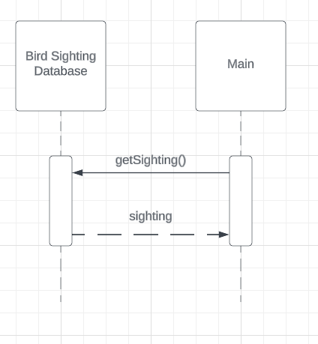

Sequence Diagram to Receive Sighting Information